**Unviling the market insights: Analysis Spending Behavior and Identifying Opportunities of Growth**

1.Introduction

1.1.Overview

1.2.Purpose

2.Problem Statement & Design Thinking

2.1.Empathy Map:

2.2.Ideation & Brainstorming Map

3.Result

4.Advantages & Disadvantages

5.Applications

6.Conclution

7.Future Scope

***1.Introduction:***

Wholesale customer analysis is a critical process that businesses undertake to gain a deeper understanding of their wholesale customers and their purchasing behavior. This strategic practice involves the collection, interpretation, and utilization of data to make informed decisions and optimize the relationships with wholesale clients. By conducting a comprehensive wholesale customer analysis, companies can enhance their product offerings, streamline operations, and ultimately boost profitability. In this introduction, we will delve into the significance of wholesale customer analysis, the key objectives it aims to achieve, and the methods and tools employed to carry out this vital business function.

***1.1.Overview:***

An overview of the topic for wholesale customer analysis provides a broad perspective on this important business practice. Wholesale customer analysis is a systematic and data-driven approach used by companies to gain insights into the behavior and preferences of their wholesale customers. It involves the collection, processing, and interpretation of various data points related to these customers, such as their buying habits, order frequency, order size, product preferences, and overall satisfaction, Enhance Customer Retention, Increase Sales and Revenue, Inventory Management, Pricing Strategy, Operational Efficiency, Product Development and Marketing.

***1.2.Purpose:***

The purpose of wholesale customer analysis is to empower businesses with actionable insights that enable them to adapt to changing market conditions, improve customer relationships, and ultimately drive growth and success in the wholesale sector. It encompasses several crucial objectives and benefits, including: Understanding Customer Behavior, Enhancing Customer Retention, Optimizing Sales Strategies, Inventory Management.

***2.Problem Statement:***

Unveiling market insights, analyzing spending behavior, and identifying growth opportunities can be a complex task. Here are some common problems: Data Quality Issues, Lack of Focus, Inadequate Tools, Overlooking Qualitative Data, Failure to Segment Data, Neglecting Competition Analysis, Poor Communication, Not Keeping Up with Trends, Lack of Long-Term Perspective. Remember that market analysis and identifying growth opportunities are ongoing processes. Regularly reassess your strategies and adapt to changing market dynamics to stay competitive and maximize your growth potential.

***2.Design Thinking:***

Design thinking can be a valuable approach in unveiling market insights, analyzing spending behavior, and identifying opportunities for growth. It provides a customer-centric, iterative, and creative problem-solving framework. Here's some design thinking, that I used in this process:

**i)Empathize:**

Start by understanding your customers and their needs. Gather data on customer behavior, preferences, and pain points. Conduct customer interviews, surveys, and observations to gain deep insights into their spending behavior and motivations.

**ii)Ideate:**

Encourage cross-functional teams to brainstorm and generate creative ideas for market analysis and growth strategies. Use techniques like brainstorming sessions and mind mapping to explore new approaches and perspectives.

***2.1.Empathy Map:***

***2.2.Ideation & Brainstorming Map:***

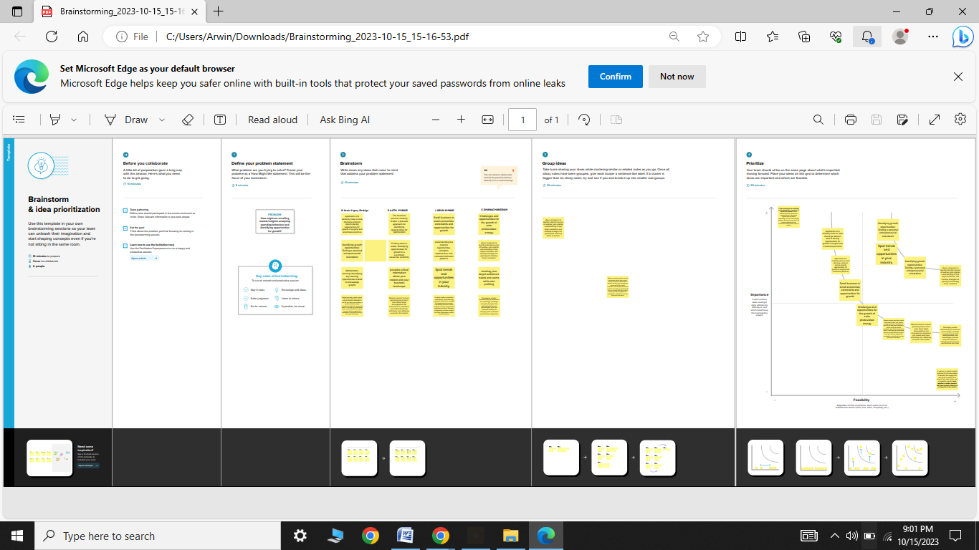

***3.Result:***

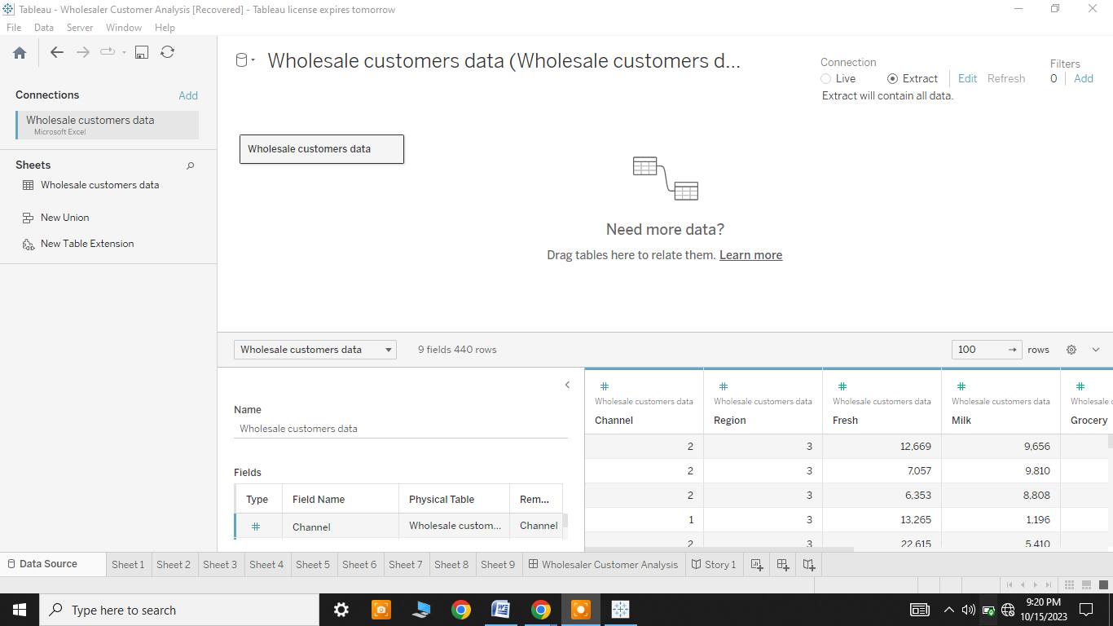

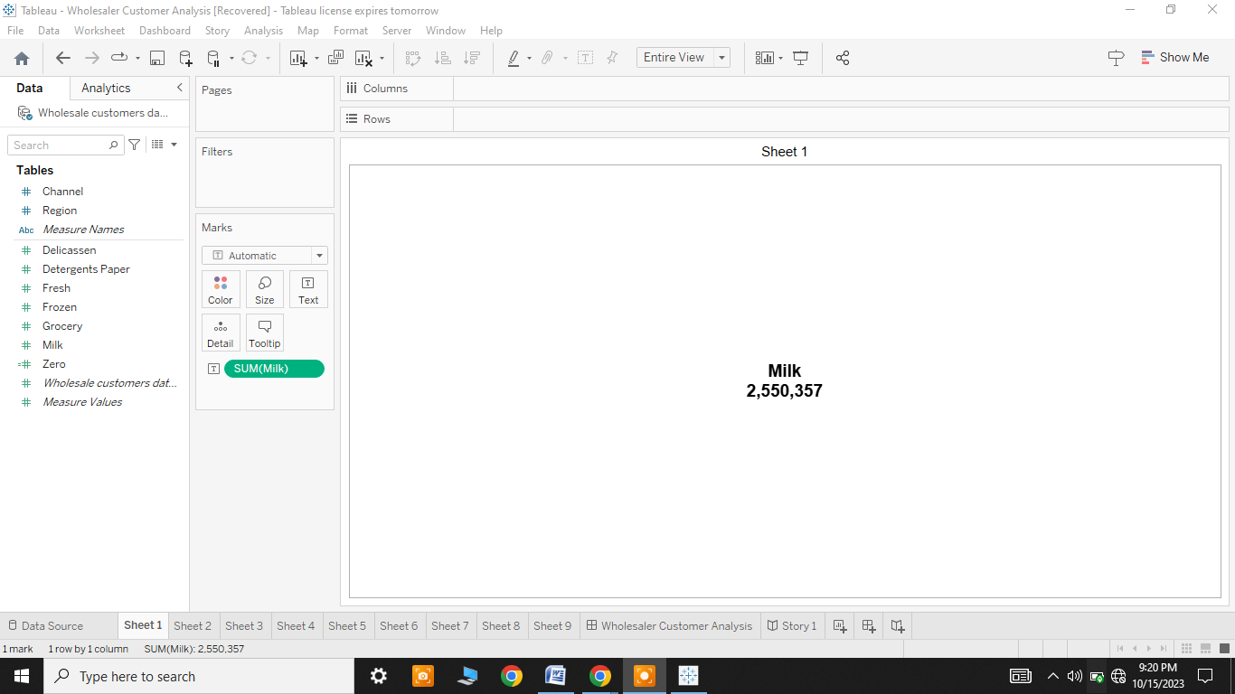

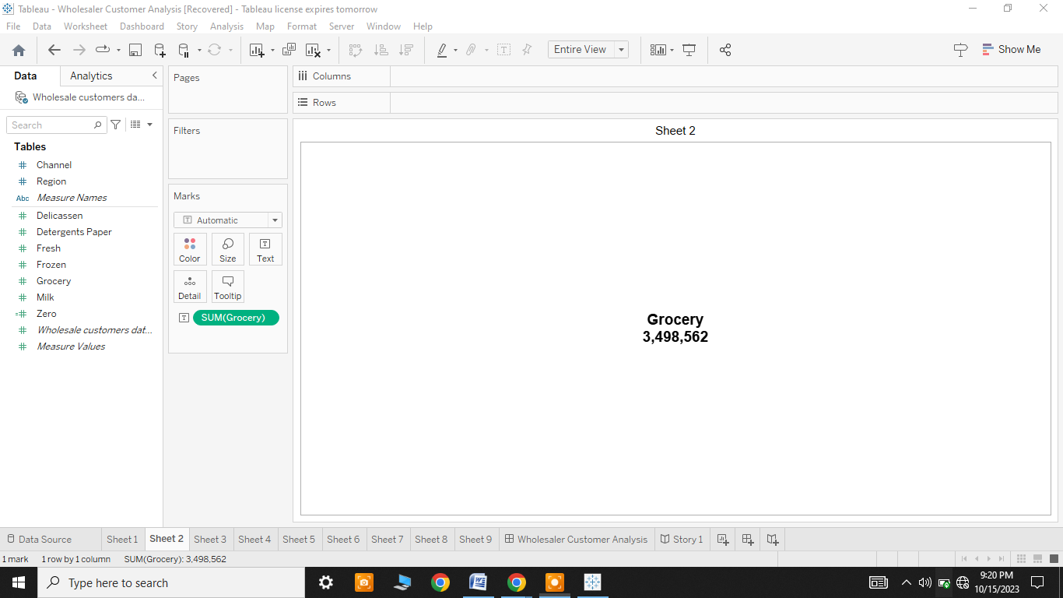

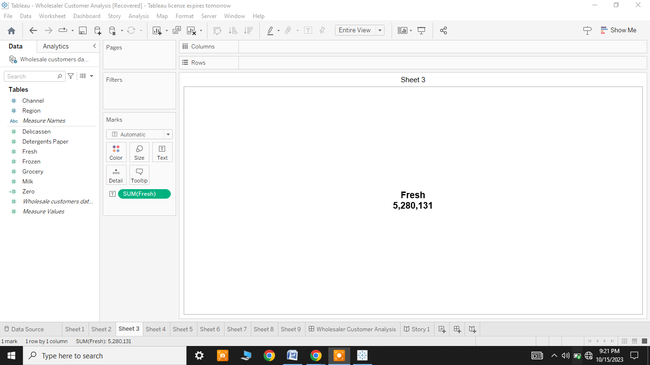 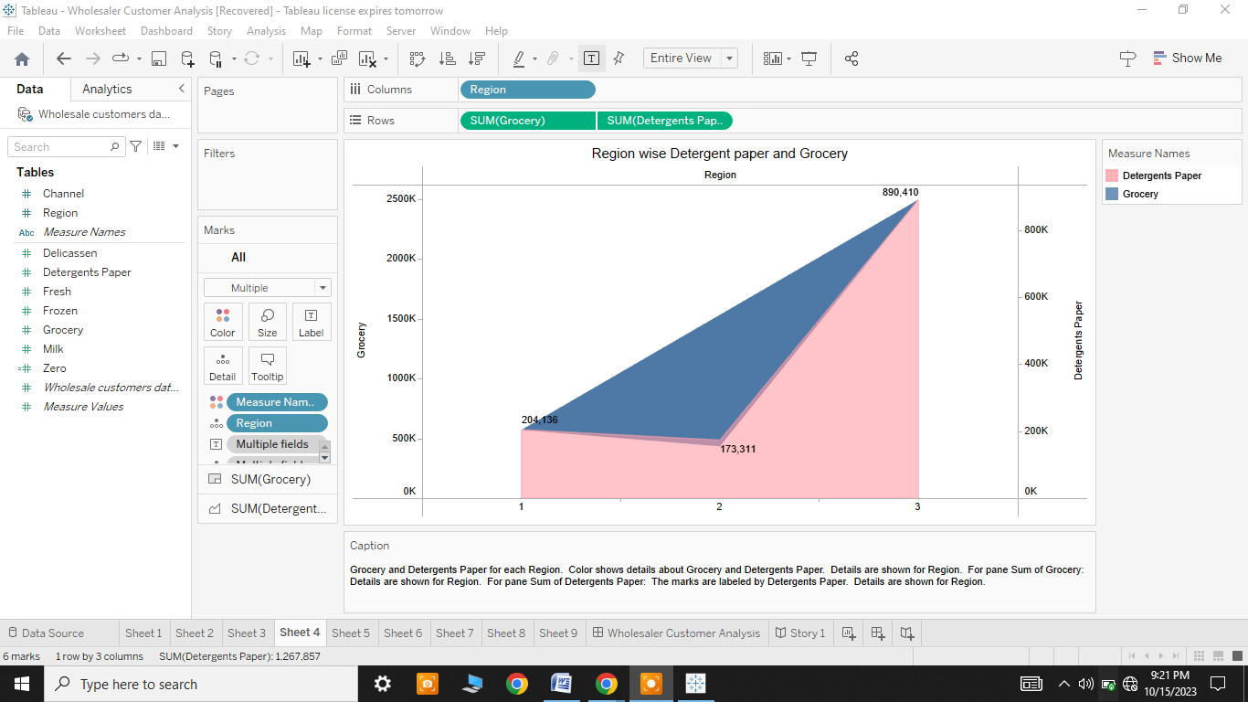

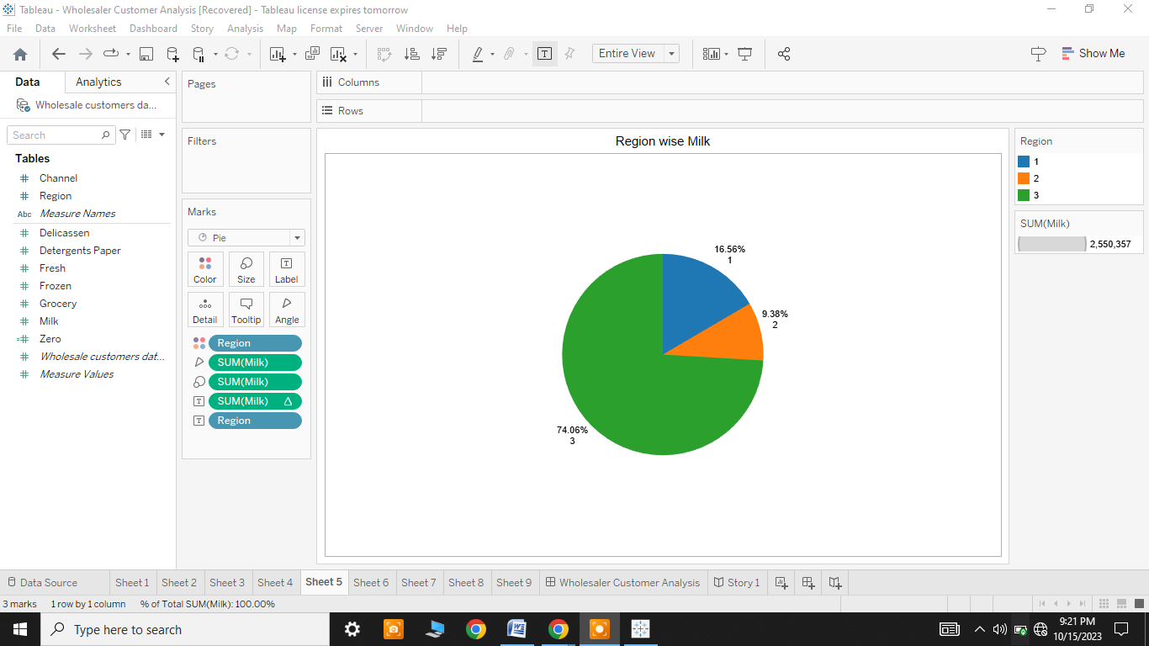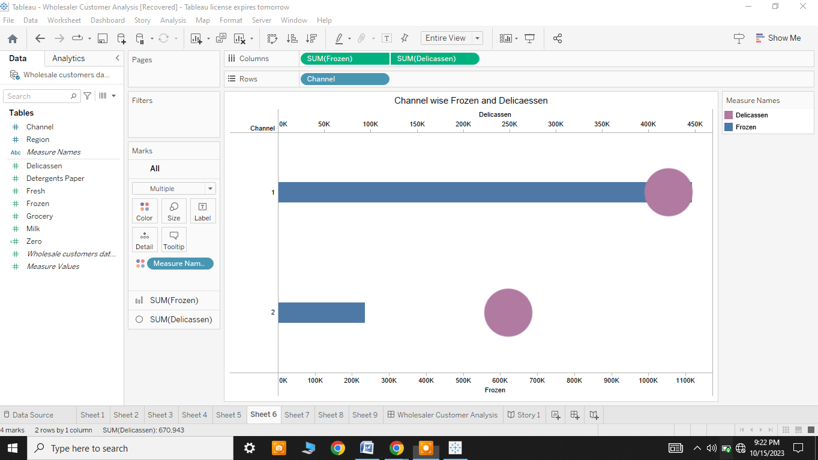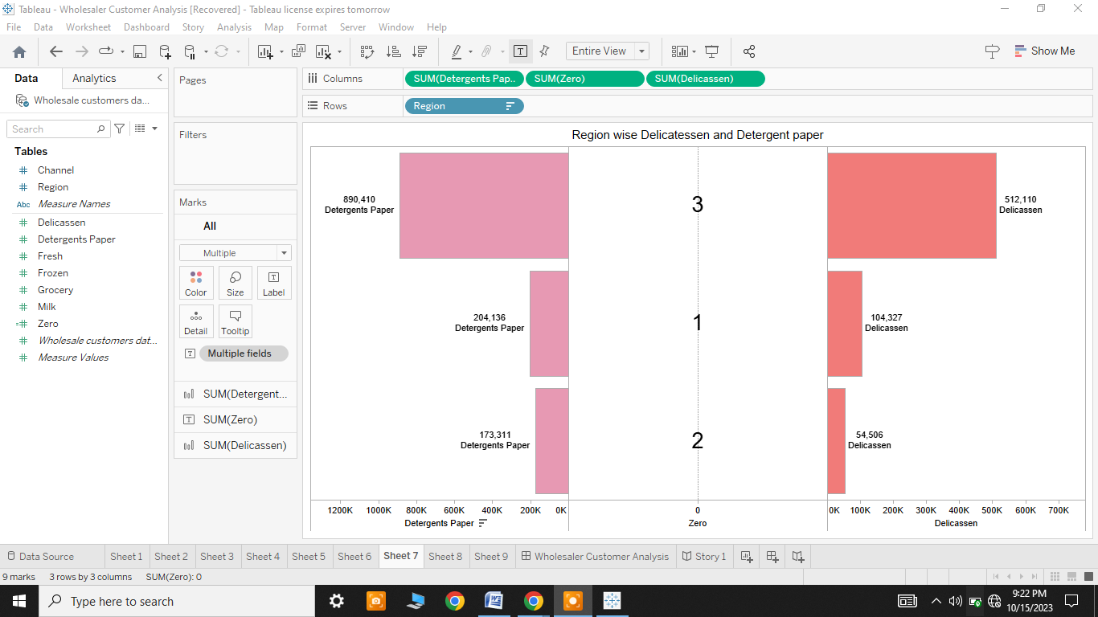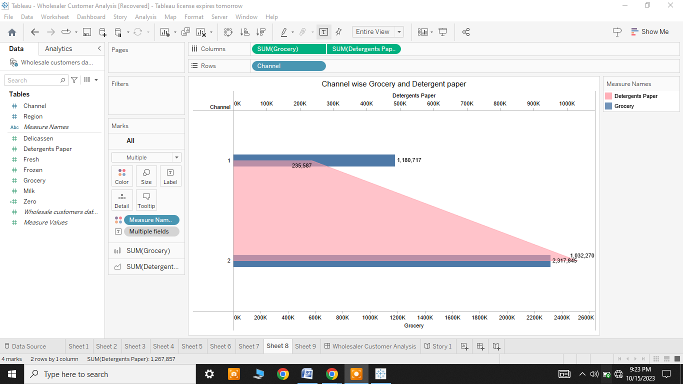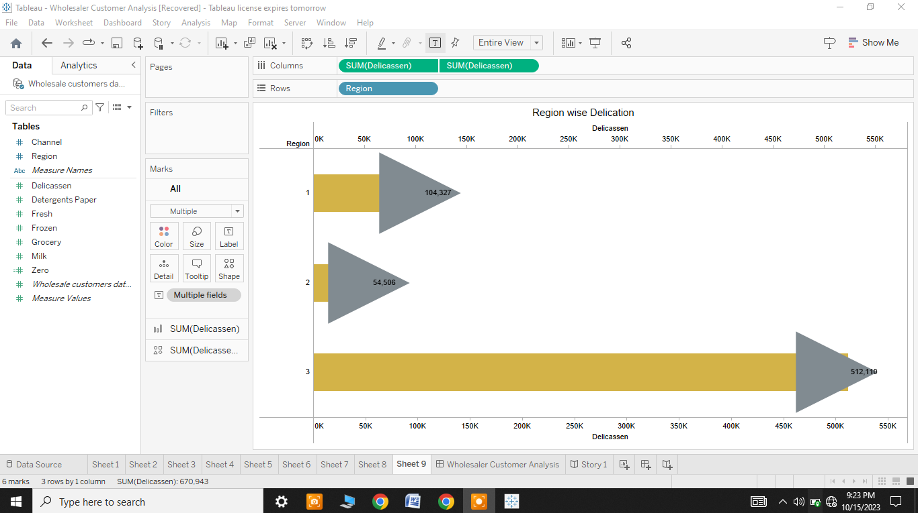

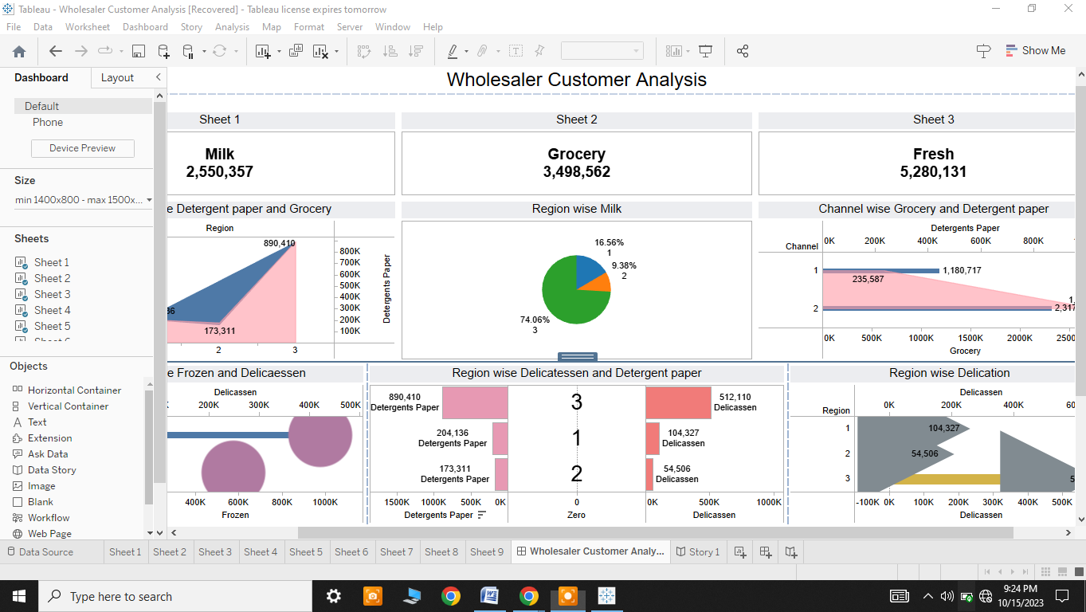

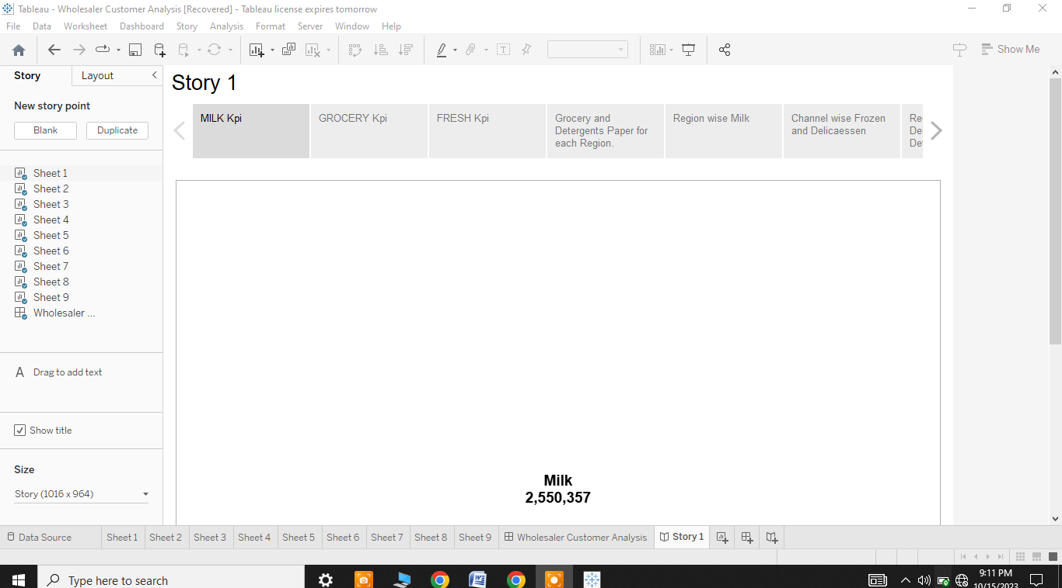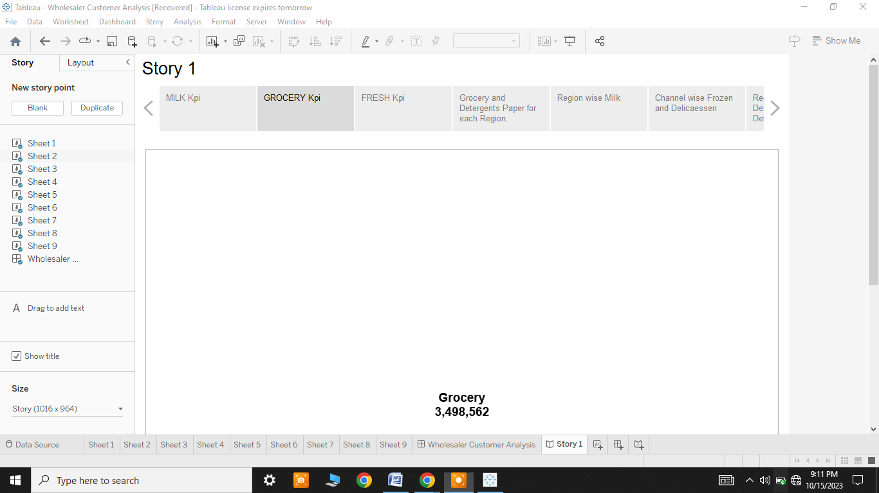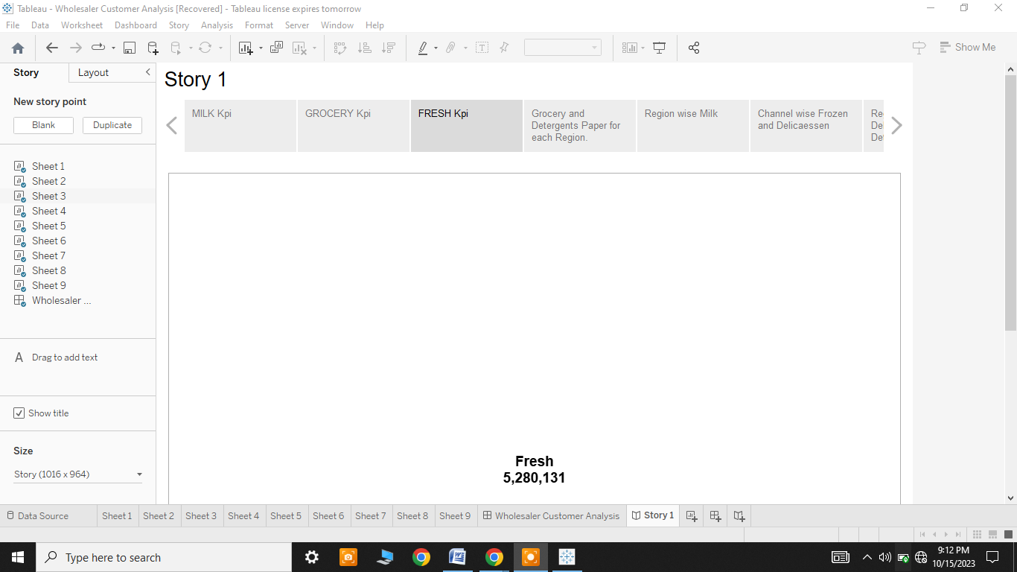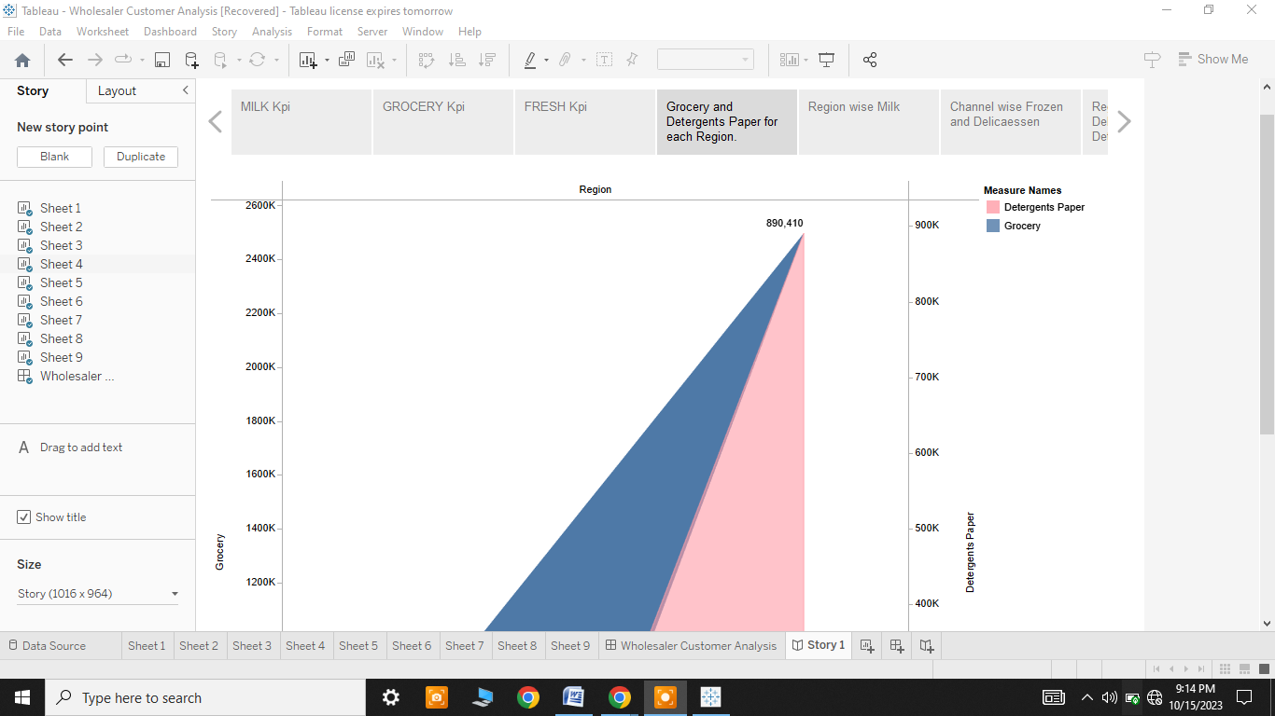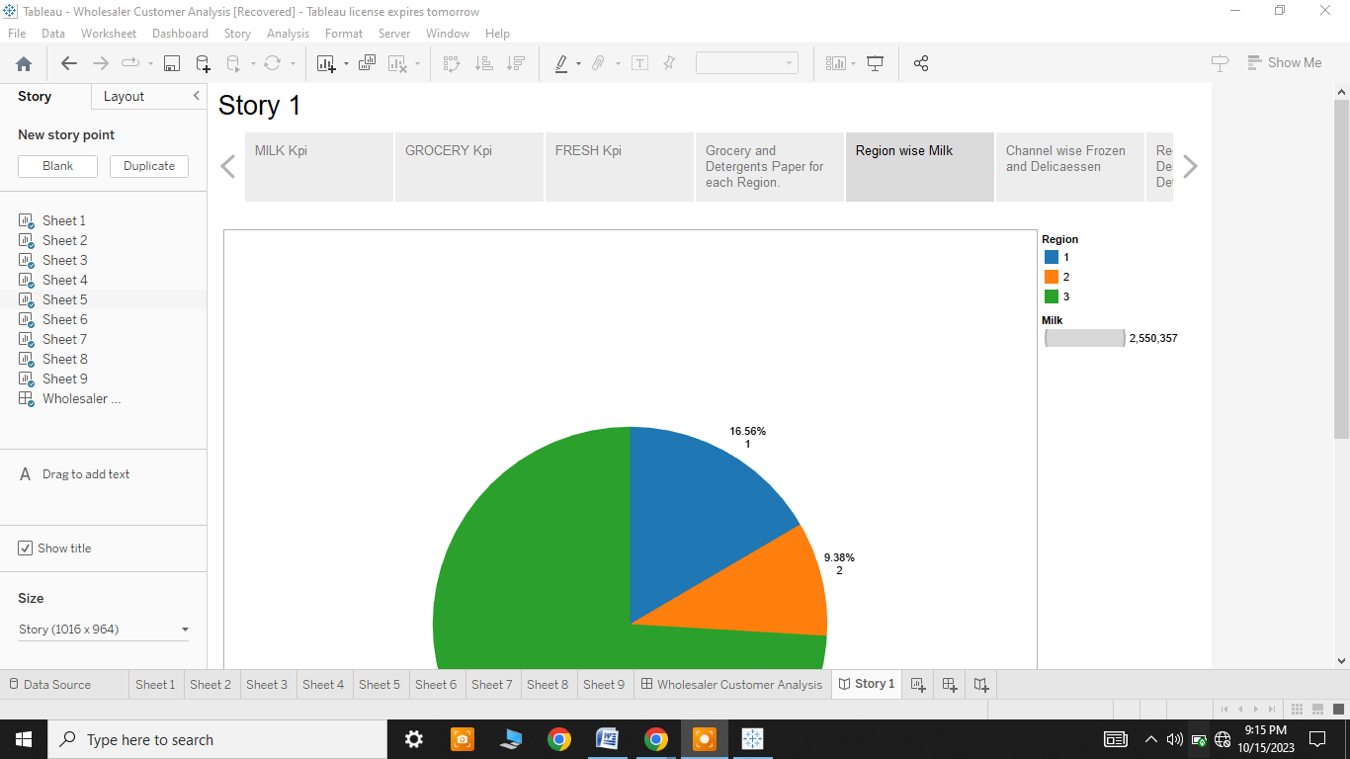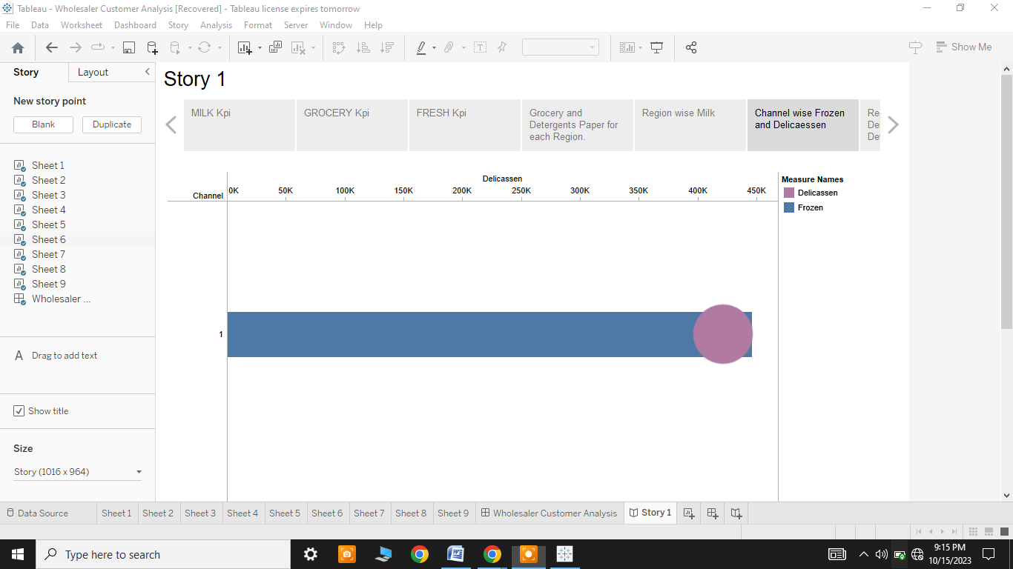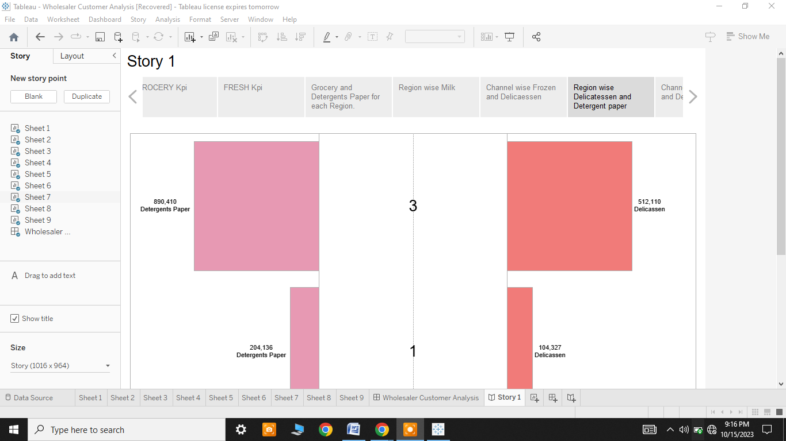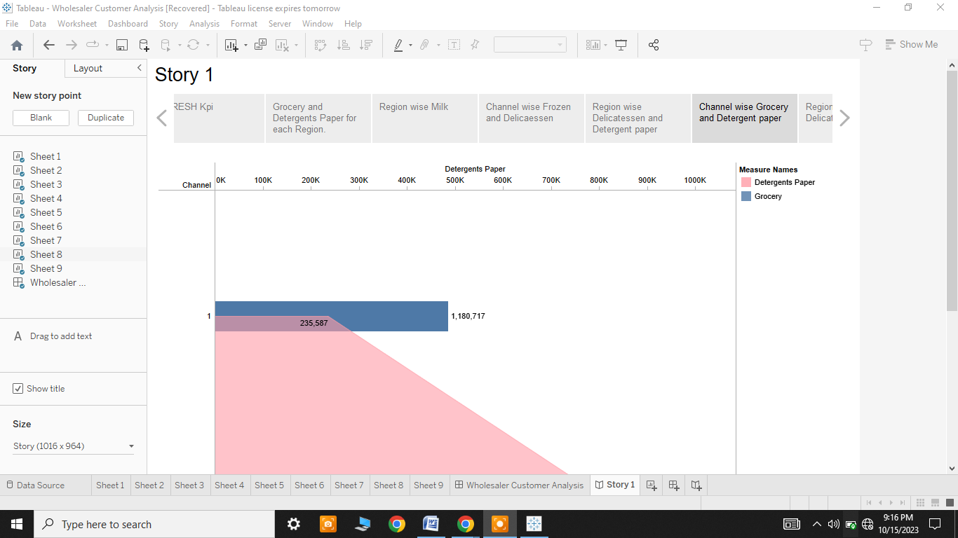

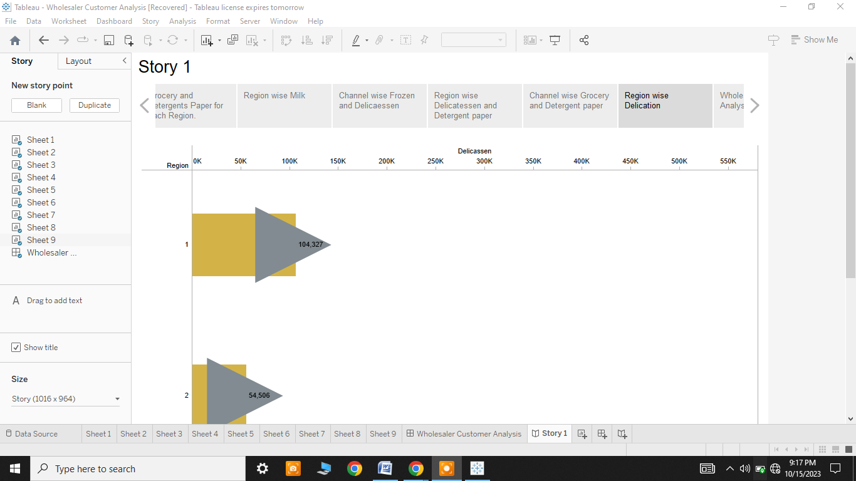

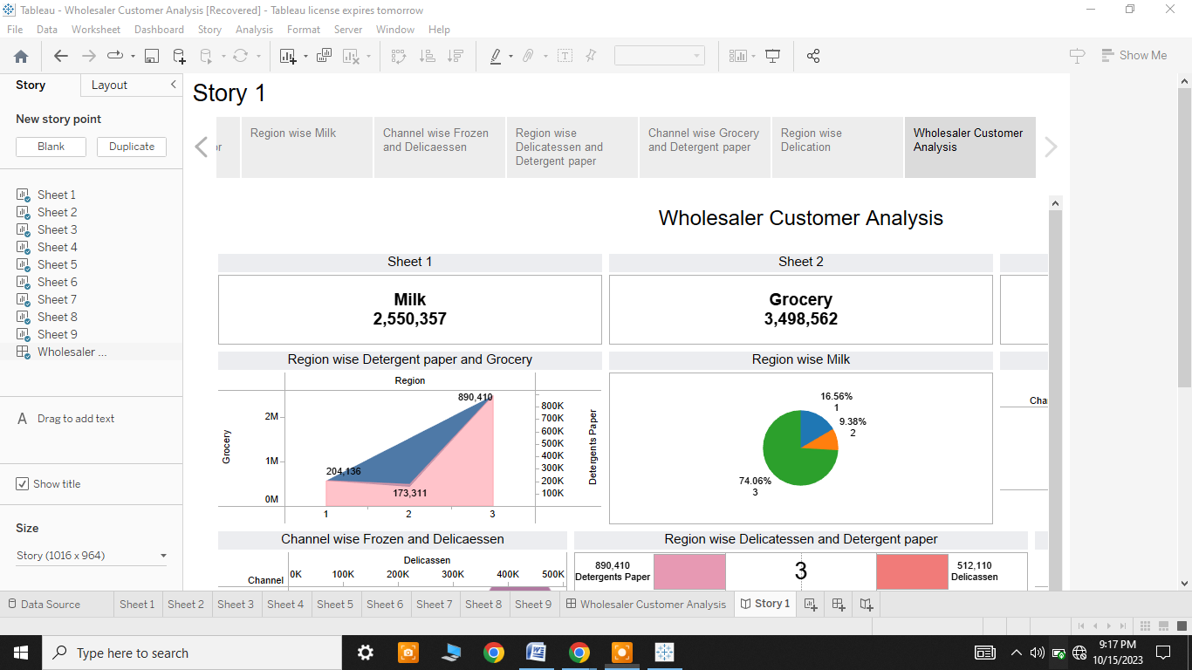

***4.Advantages & Disadvantages:***

**i) Advantages:**

Unveiling market insights, analyzing spending behavior, and identifying opportunities for growth can provide various advantages to a business or organization.

Here are some of the key benefits:

֍Informed Decision-Making

֍Improved Customer Understanding

֍Enhanced Competitive Advantage

֍Revenue Growth

֍Targeted Marketing and Personalization

֍Cost Optimization

֍Risk Mitigation

֍Customer Retention

֍Strategic Planning

֍Data-Driven Culture

֍Agility and Adaptability

֍Measurable ROI

֍Stakeholder Confidence

֍Sustainability

Overall, unveiling market insights and conducting a thorough analysis of spending behavior can provide a competitive edge, drive growth, and contribute to the overall success of a business. It helps companies adapt to changing market dynamics and deliver more value to their customers.

**ii) Disadvantages:**

While unveiling market insights, analyzing spending behavior, and identifying growth opportunities offer numerous advantages, there are also potential disadvantages and challenges to consider:

֍Data Limitations

֍Resource Intensive

֍Complexity

֍Subjectivity

֍Overreliance on Historical Data

֍Misinterpretation

֍Information Overload

֍Resistance to Change

֍Ethical and Privacy Concerns

֍Market Volatility

֍Cost-Benefit Analysis

֍Inaccurate Assumptions

Balancing the advantages and disadvantages of market analysis is crucial to make informed decisions and maximize the benefits while mitigating potential risks. Effective planning, data quality assurance, and adaptability are key to addressing these challenges.

***5.Applications:***

The application of unveiling market insights, analyzing spending behavior, and identifying opportunities for growth can be applied to various aspects of business strategy and decision-making across different industries.

Here are some applications:

֍Product Development

֍Marketing and Advertising

֍Customer Segmentation

֍Inventory Management

֍Risk Management

֍E-commerce Optimization

֍Market Positioning

֍Innovation and Research & Development

֍Public Relations and Reputation Management

Applying these insights strategically can help organizations not only adapt to changing market dynamics but also proactively shape their future growth and success. It's important to continuously monitor and update your strategies as the market evolves.

***6.Conclution:***

In conclusion, unveiling market insights through the analysis of spending behavior and the identification of growth opportunities is a crucial undertaking for businesses and organizations. It serves as a compass that guides strategic decision-making, fuels innovation, and fosters customer-centric approaches. By understanding customer preferences, market dynamics, and emerging trends, companies can position themselves for success and sustainable growth.

***7.Future Scope:***

The future scope for unveiling market insights through the analysis of spending behavior and identifying opportunities for growth is highly promising, as the business landscape continues to evolve. The future scope for unveiling market insights is expansive and holds immense potential. The ability to harness the power of data-driven decision-making and customer-centric strategies will be a critical factor in the long-term success of businesses across various industries. Companies that adapt and stay at the forefront of data analytics will be well-positioned to thrive in an increasingly data-driven world.